**Hong Kong Institute of Vocational Education (Lee Wai Lee)**

**Department of Information Technology**

**HD in Software Engineering (IT114105)**

**ITP4915M System Development Project**

**Requirement Specification**

|  |  |
| --- | --- |
| Group No. | C4 |

|  |  |  |
| --- | --- | --- |
| **Student** | **Contribution to the Project (%)** | **Signature** |
| Li Yuk Lun | 25% |  |
| Wong Ka Wa | 25% |  |
| Chu Sin Kwan | 25% |  |
| Pang Chun Lam | 25% |  |

We declare that this is a group project and that no part of this submission has been copied from any other student’s work or from any other source except where due acknowledgement is made explicitly in the text, nor has any part been written for us by another person.

**Table of Contents**

Abstract 2

1. Introduction 3

2. Problems 4

3. User Requirement 5

3.1. Functional Requirement 5

3.2. Non-Functional Requirement 12

4. Proposed System Design 14

4.1. User Interface 14

5. Project Plan 15

6. Summary 16

# Abstract

# Introduction

Ticket Tailor Ltd. is a travel agency company locates in Hong Kong with more than 30 customer service centers in the region. The company provides individual travel packages with the details of travel places, to make the hotel reservations and to arrange attraction activities. This form of travel agency services is now quickly becoming a lucrative and highly competitive business. Their services penetrate in Hong Kong, Macau and Southern area of China, and they have customers across determined to be successful through the use of information and communications technology

The objective of this management system project is to develop a system that automates the processes and activities of a travel and tourism information. The purpose is to design a system using which one can perform all operations related to travelling.

The proposed system is a Visual Studio Application and maintains a centralised repository of all related information. The system allows one to easily access the relevant information and make necessary travel arrangements. Users can select the places what the customer want to visit and make bookings for travel and accommodation for its customers.

# Problems

Explain the problems/NEEDS in the existing system from different aspects, e.g. user, department (including those listed in the scenario and discovered by your team)

# User Requirement

Below are the user requirements. We divided it into functional and non-functional requirement. We are going to investigate the requirement from different users’ view to have a comprehensive result.

## 3.1. Functional Requirement

3.1.1. For all the staff:

3.1.1.1 Staff Login System

* provide input for employee ID
* retrieve employee name after entering the employee ID
* check DB’s stored passwords that are stored in hash encryption format
* Each staff will use their staff ID or email account as a login name and password to log into the specified application.
* After logged in the system, another user form should be displayed for module selection. The form name should be “frmModuleSelection” with caption “Module Selection”.
* Wrong StaffID or Password input message should be prompted when the staff uses the invalid login information.

3.1.1.2 Module selection

* The photo of the login staff should be displayed on the top of “Module Selection” form after logged in.
* The caption “Module Selection” should be shown in the text property in the Module Selection Form.
* The default names of menu buttons in the Module Selection Form are Module1, Module2, Module3, and Module4. The form must have one more menu button <Sign Out> at the last of the menu. When the user presses the <Sign Out> button, the welcome message “Welcome! Ms. Chan, See Yum!” and the photo will be gone. Login Form will be displayed again for “Sign In”. (“Ms. Chan, See Yum” is the sample staff name which is constructed by Title + Surname + GivenName).

3.1.1.3 Air ticket enquiry module

* Create a link in the “Module Selection” form which can go to the form of “Air Ticket”
* Staff can use the textbox and other controls as the keywords to search all the data in the Flight Schedule table. The search result would be shown in the data grid.
* Number of Infant is also displayed in the input keyword UI for creating the order later on.
* In the data grid, show the Airline photos and IATA codes of “Airline” in ALL upper letter case instead of Chinese name, the Airline table with IATA codes
* All of the searching results of air ticket must be shown in the data grid which is bounded in the first tab control called “Default” such as fight no., all date and time of flight schedule, flight class, prices and tax. The “Default” tab control is showing the air ticket result by departure date in ascending.
* Tax should be calculated as 7.5% of ticket price.
* The second tab control called “Departure” is showing the air ticket result by departure time in ascending.
* The third tab control called “Arrival” is showing the air ticket result by arrival time in descending.
* The forth tab control called “Price” is showing the air ticket result by ticket price in ascending.
* Some of the flight schedules are using direct flight mode to take the passengers to the destination directly. Some are using indirect flight schedules which is more than one route. The system must handle this situation to show the detailed indirect flight info to the users when the user selects an indirect flight record.
* A button <Order> should be prepared in each air ticket line for ticket ordering.

3.1.1.4 Hotel Schedule Enquiry Module

* Create a link in the “Module Selection” form which can go to the form of “Hotel Schedule Enquiry”
* Two data grids for storing the hotel and hotel room retails.
* Staff can use the textbox and other controls as the keywords to search all the data in the Hotel Schedule table.
* Allocate the destination, check-in date and check-out date as the input UI for hotel enquiry. The basic hotel information (search result) should be listed in the first data grid. It includes hotel name, star rating, region, address. The detail hotel information will be listed in the second data grid such as room size, room type, room description, fare and etc.
* The search result of hotel information would be shown in the first data grid. When the staff select a record of the first data grid, the hotel room details would be displayed in the second data grid.
* Available hotel room should be displayed in the combo box. When the user select the combo box, the relevant room price would be displayed to the users.
* Four buttons are created on the top of the result data grid. The first (default) is for showing the hotel schedule by the “Name” in English.
* The second button is showing the hotel schedule by the “Rating” in descending. The number of rating will not showed in the data grid.
* The third button is showing the hotel schedule by “Price” in ascending.
* The forth button is showing the hotel schedule by “Star” in descending
* A button “Reserve” should be prepared in each room details line for room reservation.

3.1.1.5 Air Ticket Order and Hotel Schedule Reservation

* When the staff order the air ticket and hotel schedule for the customers, all the related orders will be displayed in this form.
* The orders will be divided into two major parts in one single form. The upper part of the form is Air Ticket, the lower part of the form is Hotel Schedule. Two parts also have an amount of order subtotal. A grand total should be displayed on the bottom of the form.
* Each part should have a separator with title and line to distinguish which part of order are displaying to the staff.
* For promoting the bundle discount to the customer who orders both air ticket and hotel schedule, $150 discount will be offered to the customer.
* In order to promote the other discount to the special customers, they will receive 10% extra discount when the year of birth is 1976, 1977, 1985, 1991.
* All the discount amount should be displayed in the order form.
* A <Confirm Order> and <Cancel Order> buttons should be created for saving the order into the database. The structure of air ticket order table and hotel schedule order table can be found in this session folder. You must create the order related table first for saving these orders.
* The minimum order of hotel reservation is 1 night, a “default” setting in the form. When the field of night is zero, the button <Confirm Order> would be disabled.
* The system needs to process the order (save the orders into the database) when the staff presses the <Order> button, the form will be gone.
* The system have to cancel the order when the staff press the <Cancel> button, the form will be gone but it needs to extract the order records into an external file (Excel, PDF or Text file) to the customer as a reference information. Once the external file is ready, the system is required to open the text file for the customer automatically.

3.1.1.6 Cruise Tour Enquiry Form and Attraction Enquiry Form

* Create a link in the “Module Selection” form which can go to the form of “Cruise Tour Enquiry”
* In the cruise tour form, start date and cruise organiser should be the search keywords for cruise tour information. All the information in the “CruiseSchedule” table should be displayed in the form after the searching is done. The staff should select at least one criteria to search the cruise tour. Otherwise, a message would be promoted for no selection.
* All of the listed information of cruise tour lines must be grouped by tour day.
* A button <book> should be prepared in each cruise tour line for the cruise ordering.
* Create a link in the “Module Selection” form which can go to the form of “Attraction Enquiry”
* In the attraction enquiry form, city name is used as a search key to list all related attraction details to the staff. When the user type the keywords in the textbox (e.g. “Tok”, it will show the related available city for the selection automatically, like “Tokyo”).
* The search is a grid format with a photo, attraction name, duration, cancellation and all the price type (e.g. Adult and Child).
* The prices of the booking are divided into the category of admission tickets. Show all the possible category prices in the searching results. Normally, it has adult and child. The format of displaying ticket prices is “price / category”, e.g. “$200 / Adult”. If it have other category prices to show, it can be showed in the next line.
* The staff can click the “attraction photo” or click the <Order> button to link to the ordering form. The <Order> button should be appeared behind the price (up or down). The ordering process will be introduced and implemented in the next session.

3.1.1.7 Cruise Tour Booking Module

* When the staff select a cruise tour line for booking, they can click <Book> button to reserve the tour.
* Display all booking information in the Cruise Tour Booking form.
* All of the related labels should be added in the Cruise Tour Booking form.
* A combo box should be prepared for selecting a customer to the booking.
* The tour fares are listed in the “CruiseSchedule” table. The default number of adult is 1, staff can modify the number of participant which is required by the customer. For the price of child, it is calculated as 60% of adult price.
* Basically, all the controls in the booking form cannot be modified except the number of participant. When the number of participant is updated by staff, the subtotal and the grand total should be re-calculated.
* PDF file is needed and showed in the Cruise Tour Booking form for customer enquiry.
* The buttons <Confirm> and <Cancel> should be ready for staff to confirm the ordering process or cancel the booking. The confirmed booking records should be saved into the “CruiseBooking” table.

3.1.1.8 Attraction Booking Module

* When the staff select an attraction line for booking, they can click <Order> button to reserve the attraction.
* Display all booking information in the Attraction Booking form.
* All of the related labels should be added in the Attraction Booking form.
* A combo box should be prepared for selecting a customer to the booking.
* All the attraction prices are listed in the “AttractPrice” table. The default number of adult is 1, staff can modify the number of participant which is required by the customer.
* Basically, all the controls in the booking form cannot be modified except the number of participant. When the number of participant is updated by staff, the subtotal and the grand total should be re-calculated.
* Some of the attractions have a different level of admission tickets, show the all possible ticket packages to the attraction booking form and leave the number of participant as zero. Default package name is “Standard”.
* The buttons and should be ready for staff to confirm the ordering process or cancel the booking. The confirmed booking records should be saved into the “AttractionBooking” table.

3.1.1.9 Transportation Fleet Management Module

* Create a sub-menu under the attraction menu in the “Module Selection” form which can go to the form of “Transportation Fleet Management”.
* Arrange the column data of “Vehicle Type” in the proper format. For example, “car” will be transformed to the proper format “Car”.
* In the form of Transportation Fleet Management, a data grid of Attraction Booking is displayed for the staff selection. A combo box should be created for showing attraction customer which is on the top of data grid. It is for filtering the attraction booking records. This grid is bounded by a groupbox control with the caption called “Attraction Booking”.
* Create a tab control with two pages under the first data grid. The second data grid will be placed in the first page of the Tab control provided by Visual Studio. The second tab is for showing booked vehicle with its attraction.
* In the first tab, the second data grid will appear here that is for showing all vehicle details from the “Vehicle” table. By default, if no selection in the first grid, no data will show in the second grid. A combo box is ready on the top of the second grid for filtering the Vehicle Type.
* The second data grid with the Tab control is bounded by a groupbox control with the caption called “Transportation”.
* The staff will click the button to pass the booking record to the Booking tab. The status will be changed to “Car” or “Coach” that is belongs to the type booked vehicle and it will be saved into the attraction booking record. The button will be placed in each vehicle details line in the second data grid.
* In the second page of tab control, the status information must be “bold” in “red” color when the status is not equal to “Confirmed”. If it is equal to “Confirmed”, it will be “bold” and changed to “blue” color.
* The third data grid is for showing the equipment details for staff selection. By default, the equipment data grid will only show the particular type of record which depends on the selected type of vehicle from the first tab.
* Staff will select date from the “Pick-up Date” and “Drop-off Date”, the “Book Day” will be calculated automatically. The transportation charges will be calculated by times the book day because transportation charge is counted per day. The equipment charge is a one-off item and NOT counted per day.
* Staff needs to click <Confirm> button to confirm the booking. Then, the status will be changed to “Confirm” and it will be saved into the attraction booking record. Before the status “Confirmed”, button is disabled for user click. <Cancel> button is anytime available for cancel this booking. <OK> button is for saving all the transportation booking with its equipment to the equipment list table.
* The confirmed transportation booking records should be saved into “VehicleBooking” table.
* Staff can select more than one equipment for the vehicle booking, the equipment charges will be accumulated and displayed in the textbox of “Equipment Charges”. The equipment booking will be saved into the “EquipmentList” table.

3.1.1.10 Driver and Roster for Transportation Bookings

* If the customer book an attraction with a coach booking, available drivers will be shown in a list box for selection. The system will check the pick-up date and compare with the driver roster to show the available drivers. List box should be disabled with default listed item “Non-available” when the customer booked an attraction with a car booking.
* According to the driver roster, the driver cost will be increased 1.5 times when the pick-up date is weekend.
* When the staff select a driver from the list box, a confirmation dialog will be prompted for assigning the driver to the coach. The status will be changed to “Driver” and saved it into the attraction booking record.
* If the attraction record is in “Coach” state, <Confirm> and <OK> buttons would be disabled. Once the state changed from “Coach” to “Driver”, button would be released.
* Implement the checking mechanism for avoiding the customer to select the booked requirements again for the booked vehicle.

3.1.1.11 Data Report of All Bookings

* Create a link in the “Module Selection” form which can go to the form of “Data Report of All Bookings”
* The report should contain all relevant details with booked fees. The subtotal shows the total fees of each type of bookings and grand total shows total fees of all subtotal for a particular customer. The staff can select a customer from a combo box to generate the report.
* Four buttons should be created on the top of form to generate a WORD or PDF document as a record that is a booking confirmation for the particular customer. The four buttons include <Flight>, <Hotel>, <Cruise> and <Attraction>. The attraction booking should have the related vehicle bookings (if any).
* Staff should select a customer in the All Bookings Form and then generate the confirmation document for the particular bookings. An error message should be prompted if the staff do not select a customer and click one of the buttons to generate the document.
* When it is in the situation of no record showed for the particular bookings in the Data Report of All Bookings, the words “No bookings” in bold with corresponding color will be displayed.

3.1.2. For the Sales managers and account managers:

(include the function of staff)

3.1.2.1 Data Reports / Graphics for Data Analysis

* Create a submenu called “Performance” under the menu “Data Report” in the form of Module Selection.
* All reports / graphics should be show in the Tab page in a Tap control. The name of the tap should be follow the titled data report / graphic.
* Data report with bar chart of a staff with his salary and retirement fund deductions with the title “Salary and Retirement Fund”.
* Data report with bar chart of a staff with his/her salary (including cash prize/deduction), shop bonus, individual bonus, sales prize with the title “Total Payment for a Staff”.
* Data report with pie chart of Center ID with its center bonus with title “Center Bonus”.
* Graphs showing FIVE top sales staff with number of customer with the title “Top Five Sales Staff”.
* Graphs showing FIVE top sales staff with sales amount with title “Top Five Sales amount” in descending order of its amount (from left to right) and this should be indicated by an arrow, highlighted in the chart.
* A combo box should be created in the form selecting a customer for the particular report if it is required.

3.1.3. For the customer:

(A web based system include the function of staff except the login page and the account information)

3.1.4. For the system:

3.1.4.1 Flight Schedule and Hotel Schedule Tables

* Name the database called “ticketTailor_db”.
* Name the table called according to the tab name which is stored in the EXCEL files (FlightInfo.xlsx and HotelInfo.xlsx).
* Build the right relationship between the tables if it is necessary.
* Apply to all fields of ticket fare is numeric with no decimal place.
* FlightID is for the FlightSchedule table, it is a primary key of the table.
* HotelID is for the HotelSchedule table, it is a primary key of the table.
* All ticket fares including flight schedule and hotel schedule, must be stored in a number format with no decimal place.
* The photos of carriers are available in the session folder

3.1.4.2 Staff table

* Divide the staff name into three parts which include “Title”, “Surname”, and “Given Name”. For example, the staff “Chan See Yum” should as kept as “Ms. Chan See Yum”.
* Staff ID must be under 10 digits (minimum 2 digits) and starting from lower letter. A basic authentication must be implemented for security requirements from the client.
* In order to enhance the system security, the password should be encrypted by one of the hash function like md5, sha1 or others. Decryption process will be used in verification of the password during login.
* A photo field called “StaffImage” must be stored in the Staff table. The developer can choose to store the photos or photo links in the field.

3.1.4.3 Cruise Schedule table

* The field “Info” is used for storing the PDF file name of the particular cruise tour.

3.1.4.4 Cruise Booking table

* The fields of orderDate, orderBy, CustID should be saved into the “CruiseBooking” table. orderDate is the order placing date. orderBy is the field for storing staff ID those record is operated the particular staff. CustID is storing the customer id.

3.1.4.5 Vehicle Booking table

* The fields of orderDate, orderBy should be created in the “VehicleBooking” table. orderDate is the order placing date. orderBy is the field for storing staff ID those record is operated the particular staff.
* The relevant driver cost will be recorded into vehicle booking table for salary calculation. The recorded field name is “DriverCost”.

## 3.2. Non-functional Requirement

* The font color of the air ticket order should be in “Brown”, the font color of the hotel in schedule order should be in “Black”. “Bold” effect must be applied for better viewing.
* In the attraction enquiry form, if the attraction need charged for cancellation, please highlight the data after the text “Cancellation:” in “Cranberry” color. Otherwise, show and highlight it after the text “Cancellation:” in “Teal” color.
* Use different color with 14pt font size in the subtotal and grand total of the data report for all bookings.
* The client personal information should only be accessed by the staff.
* The system interface should be in English.
* The speed of accessing the data should be fast.

# Proposed System Design

GUI would take up a lot of resource, such as CPU and ram usage

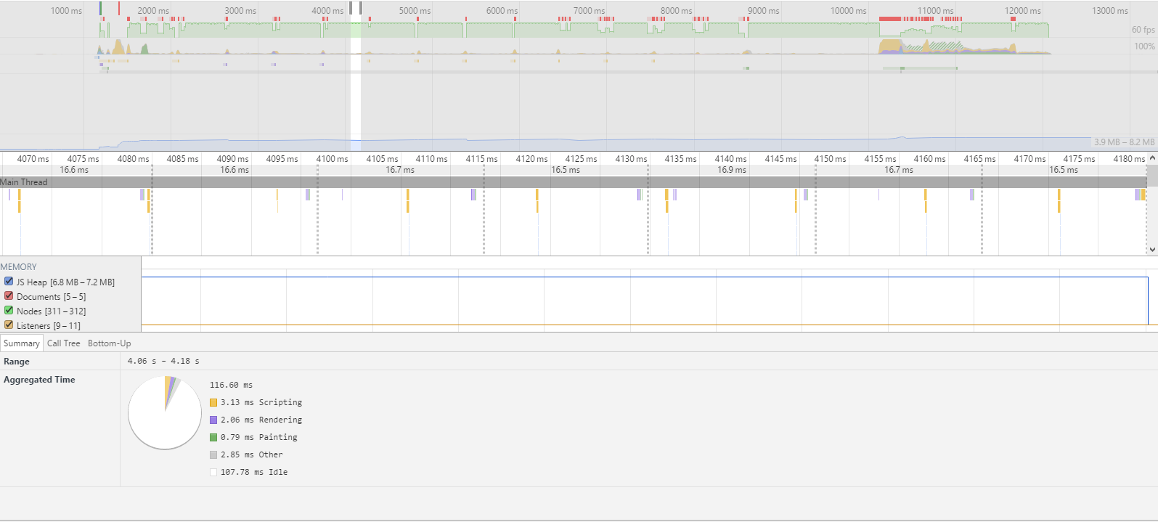

As we can see, the resource usage is not stable, when doing the render session, the whole system doing a lots of background work, it might affect the system response time and laggy.

To solve that, we will put some component rendering in batch , or increase the loading time to let browser have average resource usage by wait the system have idle resource to rendering.

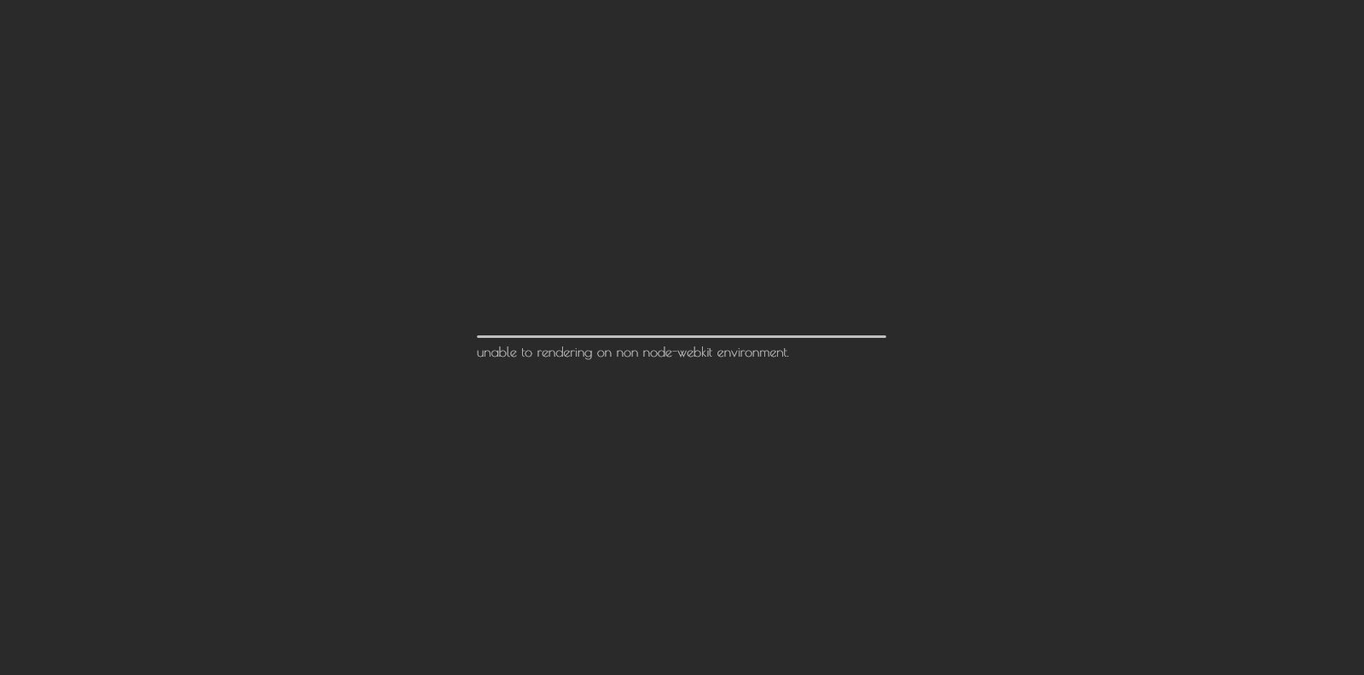

And also, the custom UI core are using Node-Webkit based, it might not applicable on some non-mainstream browser and the typesetting will have the confusion problem.

To solve that, we will use some replace solution, create a simple based UI for the specifically situation, for whom want to doing the function on lightly, lagless environment.

## 4.1. User Interface

Login

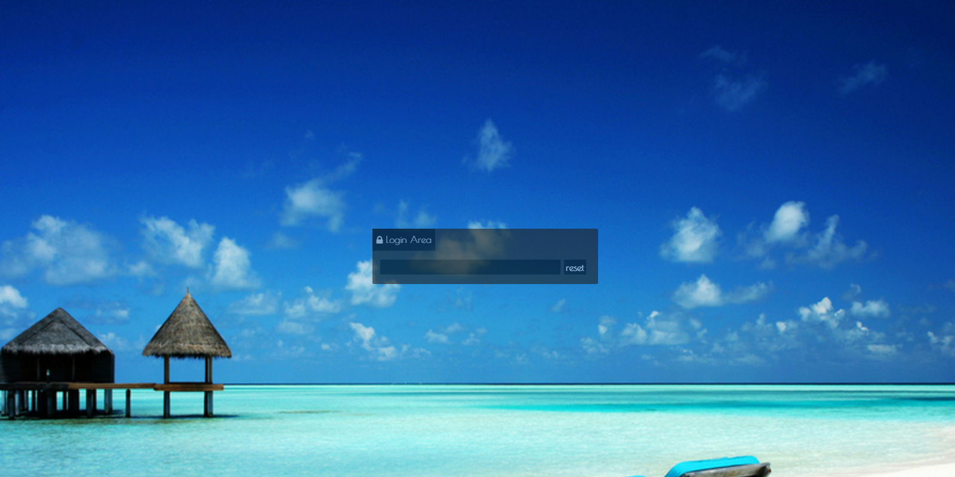

Menu

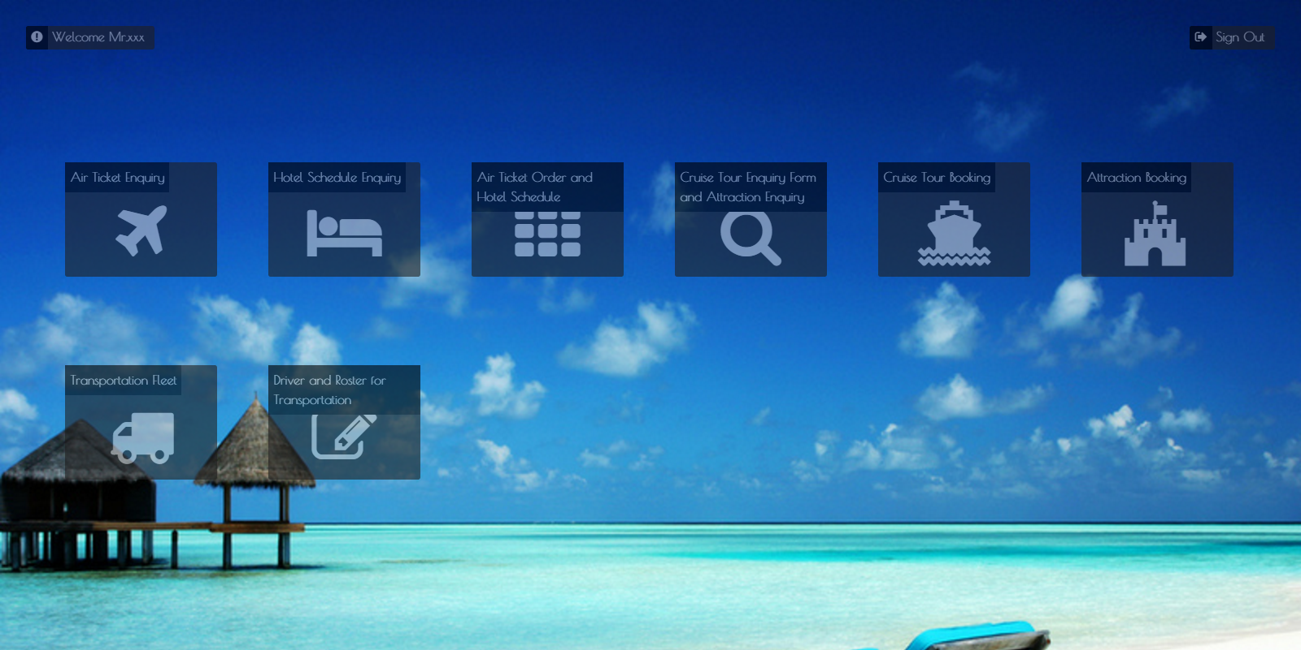

Air Ticket Enquiry

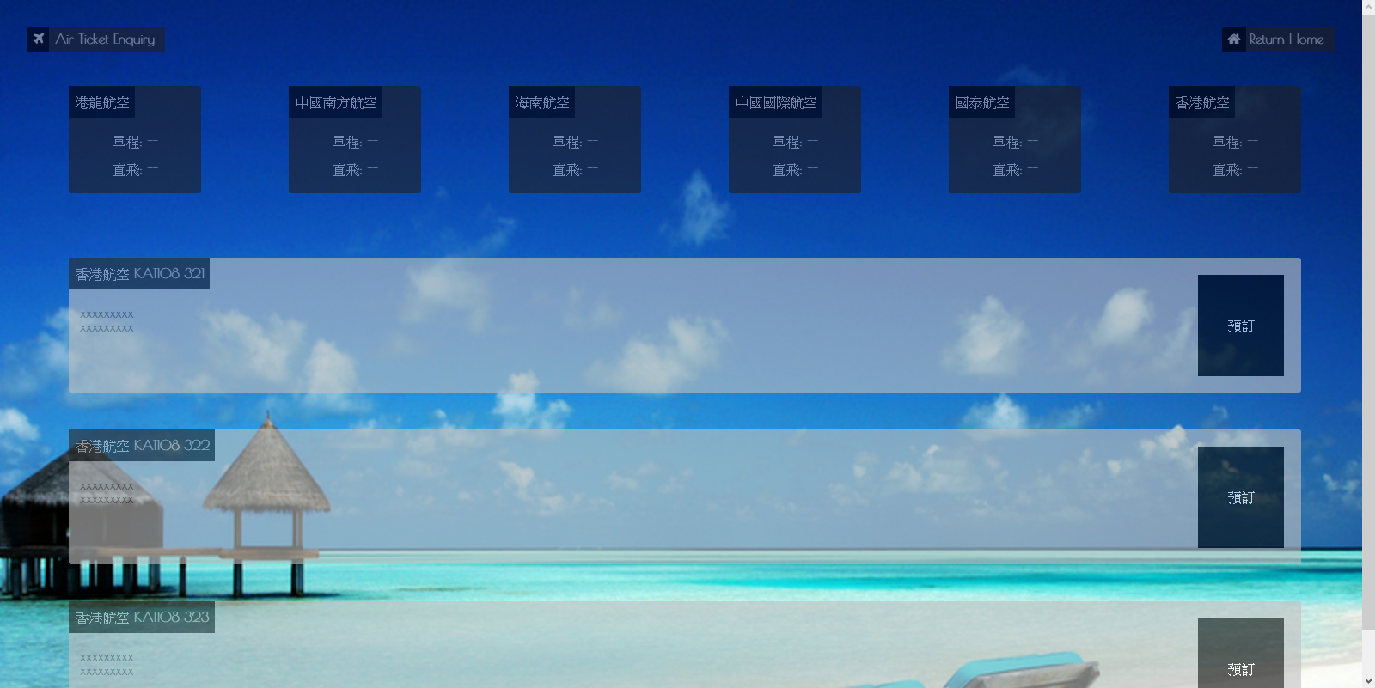

Hotel Schedule Enquiry

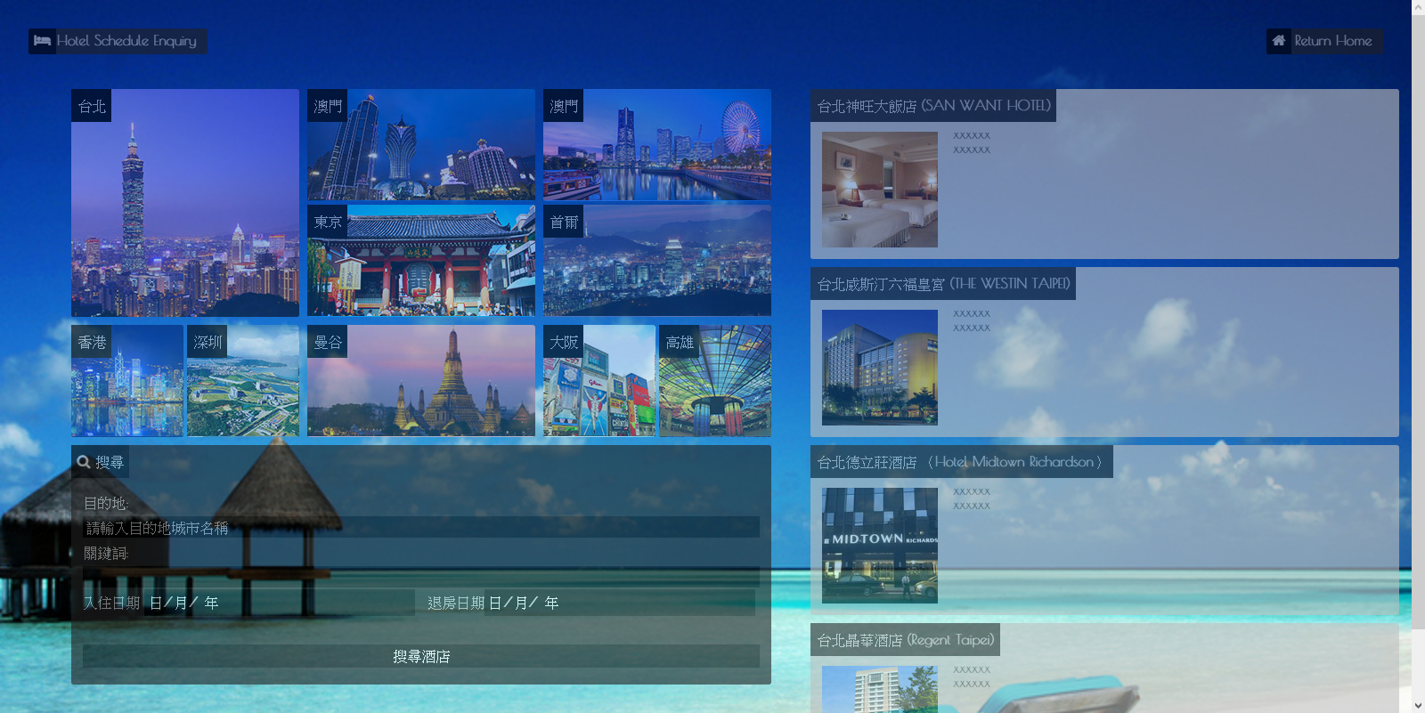

Air Ticket Order and Hotel Schedule

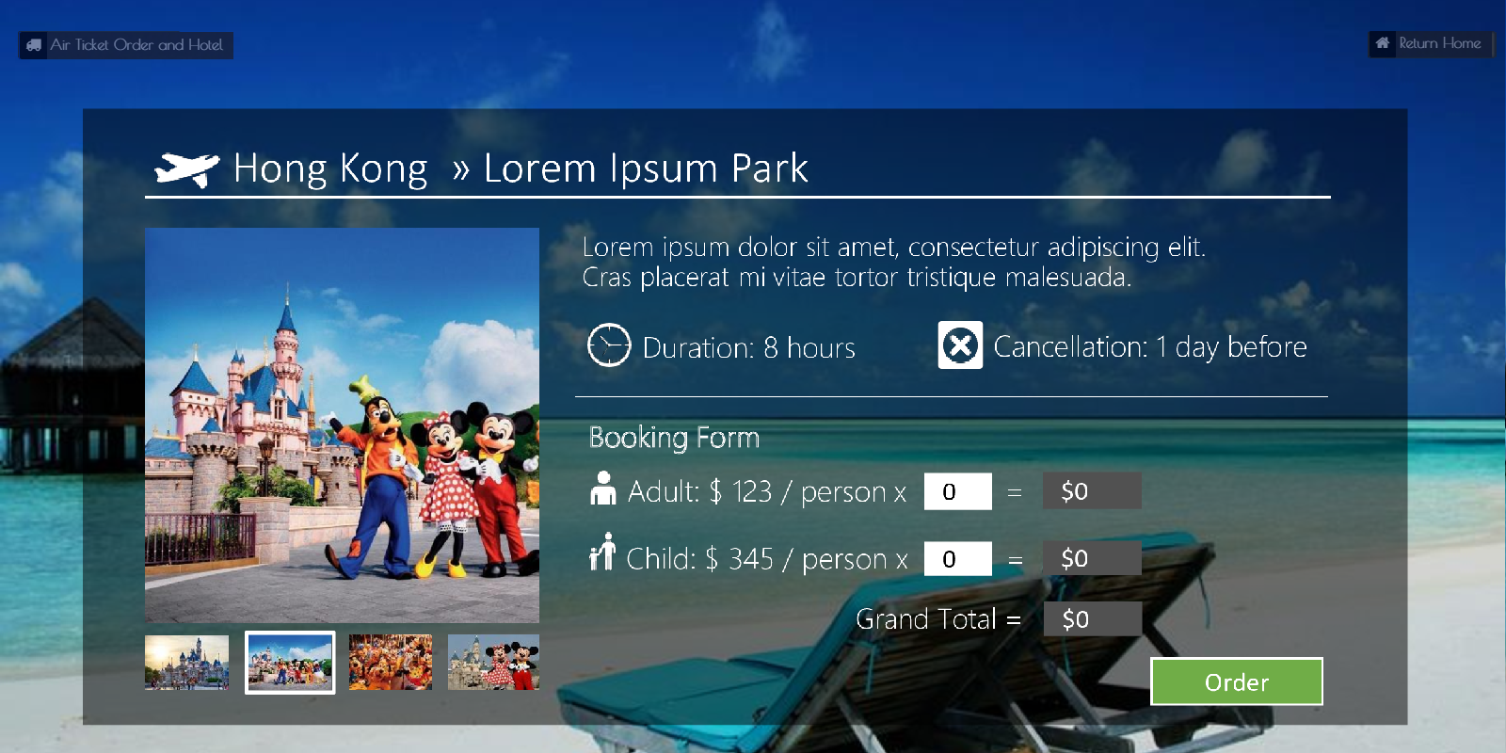

Cruise Tour Enquiry Form and Attraction Enquiry

Cruise Tour Booking

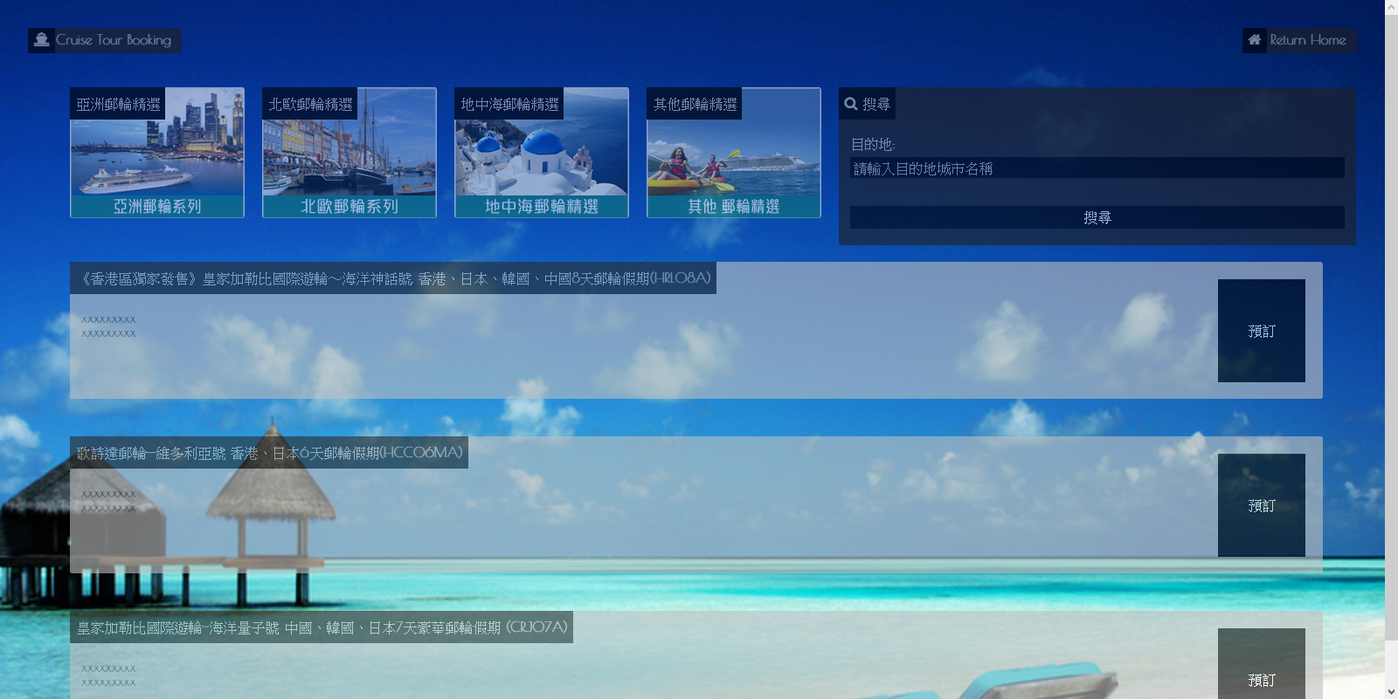

Attraction Booking

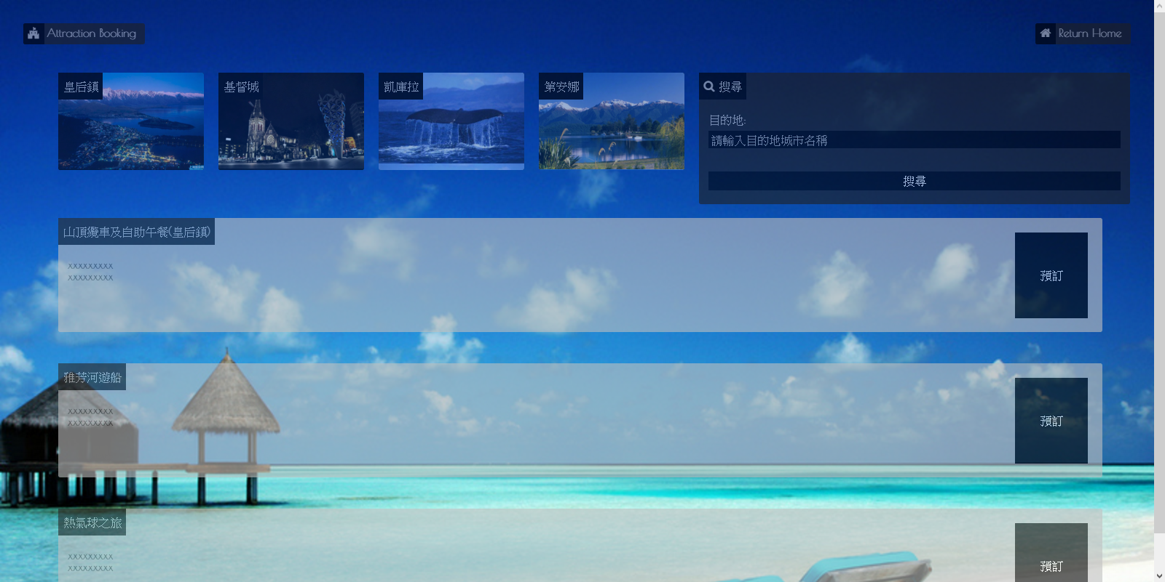

Transportation Fleet

Driver and Roster for Transportation

# Project Plan

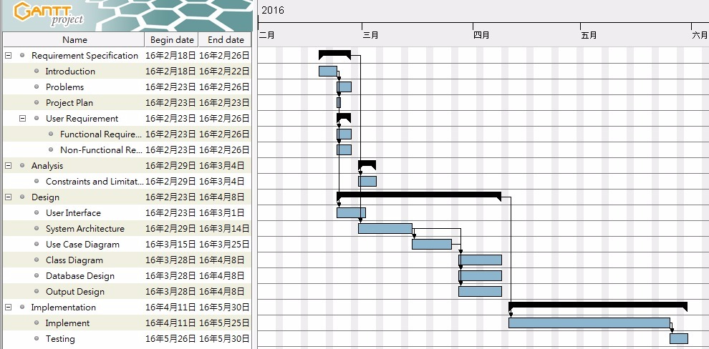

# Summary

Discuss the benefits of the proposed system